Safe and Easy Wii U SoftMod Guide
Items Needed
- Wii U on Firmware 5.5.1
- 16 Gb Class 10 SD card or Micro SD card with Adapter-Maximum 256Gb (Must be formatted FAT32)
- Powered External HDD/SSD or an External HDD with a USB Y cable up to 2TB Maximum
This will be the easiest guide to exploiting your Wii U and using the Homebrew Channel to add games and play them. This will require an internet connection and access to one of the sites that host the Homebrew exploit.
Step 1. Plug in your USB HDD and let the Wii U format it. This HDD will have to be dedicated to the Wii U, you will not be able to use it for anything else.
Step 2. Block Nintendo updates for your Wii U. There are several ways to do this, below will detail the easy way and a more advanced way if you know how to configure router settings.
Detailed Guide with Pictures to set DNS on Wii U
2a. Easy way but will depend on a DNS server to block updates. Go to settingsInternetConnect to InternetConnectionsChoose your connectionChange SettingsDNSDon’t Auto-obtainSet your primary DNS to 35.164.240.189 and the secondary to 168.235.092.108Press confirm Then back out and save and test connection when asked. (NOTE: If your internet connection fails, the DNS Servers are down. Check the Detailed Guide Link above for other alternative DNS Server addresses.)
(Advanced Options below. If you do not already know how to configure these router settings stick with Step 2a)
2b. Second way: Block the websites below on your router. (NOTE: If you plan on using a 3DS/Switch or any Nintendo product requiring updates this will prevent you from updating those devices or possibly contacting the eShop)
2c. Best way: Set up a parental control on your router for just the Wii U and block access to any of the below websites. (NOTE: This will only block the update servers for you Wii U and other Nintendo devices will still have access to them.)
- nus.cdn.c.shop.nintendowifi.net
- nus.cdn.shop.wii.com
- nus.cdn.wup.shop.nintendo.net
- nus.wup.shop.nintendo.net
- nus.c.shop.nintendowifi.net
- c.shop.nintendowifi.net
- cbvc.nintendo.net
- cbvc.cdn.nintendo.net

Step 3a. Format your SD card to FAT32. Below is a link to MiniTool Partition Wizard Free that will allow you to format drives larger than 32gb on Windows.
Mini Tool Partition Wizard Download
If your drive is 32gb or smaller just format by right clicking and choosing format and make sure FAT32 is selected as File system. If it is larger than 32Gb use the tool provided. Run the program. Select your SD card drive. Make sure it is the right drive. You do not want to format the wrong drive. Next choose format at the top and select FAT32 under File System. Click OK. Then you have to click Apply at the top of the screen to format the drive.
Step 3b.Download the files for your SD card via the link below and unzip. (Windows 7 and newer come with built in unzipping tools, otherwise download 7zip) Place the contents in the ROOT folder onto your SD card. (example: “D:\” or “E:\” is considered the root of the drive) You should have an “install” folder, a “wiiu” folder and “fw.img” on the root of your SD card.
Wii U SD Card Contents
Step 4. AFTER copying the files above to your SD card or MicroSD card with SD card adapter, put the SD card in your Wii U and launch the internet browser. Open settings and delete all saved data. Visit one of these sites listed below and bookmark it so you do not have to type it in again. Some sites will auto-launch the homebrew channel, others have a button to press. The www.loadiine.ovh site has a checkbox to auto-launch after the first visit. It can take more than 1 try sometimes but will run every time after it does load up. (NOTE: The Wii U will freeze up trying to load Homebrew for the following reasons: The SD card is not in the slot, The SD card was not formatted correctly or the files are not on the SD card. Make sure the card is formatted FAT32 and the files are on it before trying again.)
- http://loadiine.ovh/
- http://wiiubru.com/
- http://uiiw.tk
- http://sirbeethoven.github.io/Popcorn/
- http://nwplayer123.github.io/WiiU/
- http://hbl.cucco.de/
- http://git.io/wiiuhax/
- http://anus.trade/wiiu/index.html
- http://wiiu.insanenutter.com
- http://wj44.ml
- http://nintyexploits.net23.net
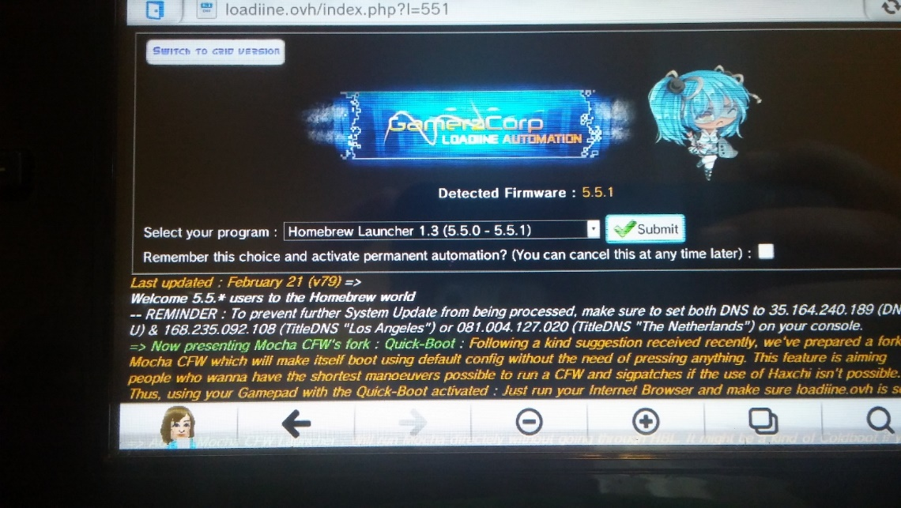
Step 5. You should now have the Homebrew Browser up and running on your Wii U with access to the apps on the SD card. (If you don’t see the page above or similar check your spelling of loadiine)
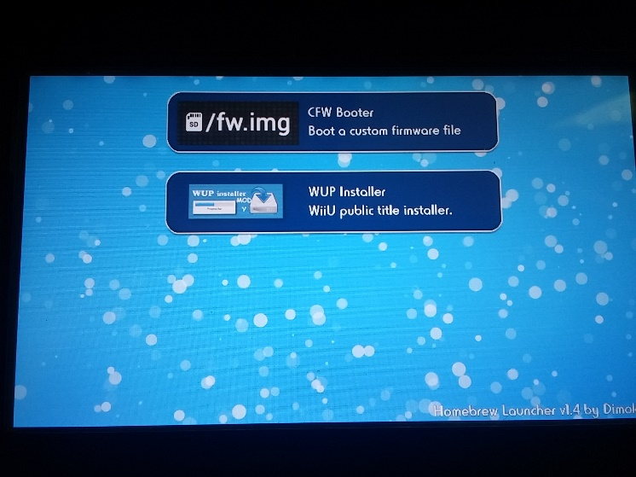
Step 6. Next step is to get some games downloaded to install onto your Wii U. Below is the link for the application to download games. Look for a “DOWNLOAD” button to download the application, create a new folder somewhere you can easily find to install the application to titled Wii U USB Helper and then place the update.exe in the folder and run it. Next it will ask you where to download your games followed by a few questions. Click agree, enter your region (USA, JPN, EU) and type wiiu.titlekeys.com for the title keys site in the address bar for Wii U. You will be able to download games, updates and DLC with this app.
Wii U USB Helper
Step 7. Once you have downloaded your game(s), you will need to transfer them to your SD card. Copy the folder or folders for the game itself (Mario Kart 8 [Random numbers]), update (will be named same as game with a version number after it) or DLC you downloaded, into the “install” folder on your SD card. Once you’ve copied the games/updates/dlc you want to transfer it should look like the image below. The image shows the game and update in the install folder. (NOTE: Be sure to install the games FIRST and then the updates or DLC afterwards. Not doing so will require you to reinstall the updates/DLC a second time after the game is installed.)
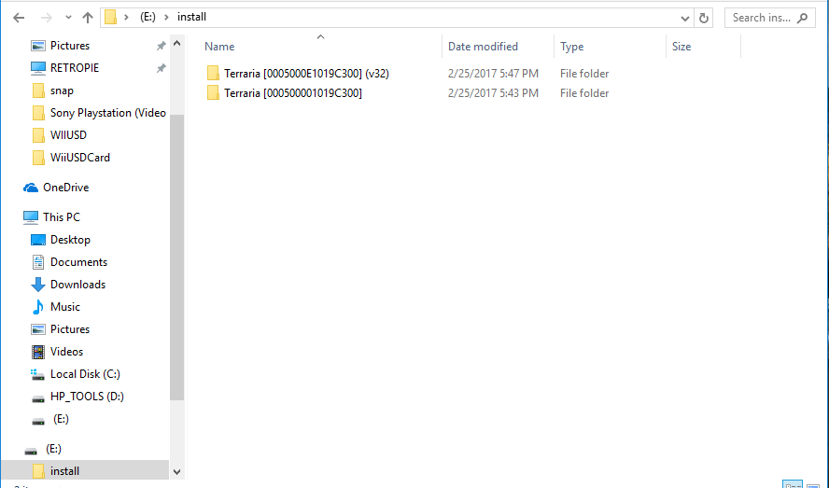

Step 8. Place the SD card back in your Wii U and launch Homebrew browser again via running the website. Next click “WUP Installer” and press load. You will be able to select your folder by pressing up or down and then hit X to install to your USB HDD. It also gives you the option to install to your system memory but I do not recommend that.
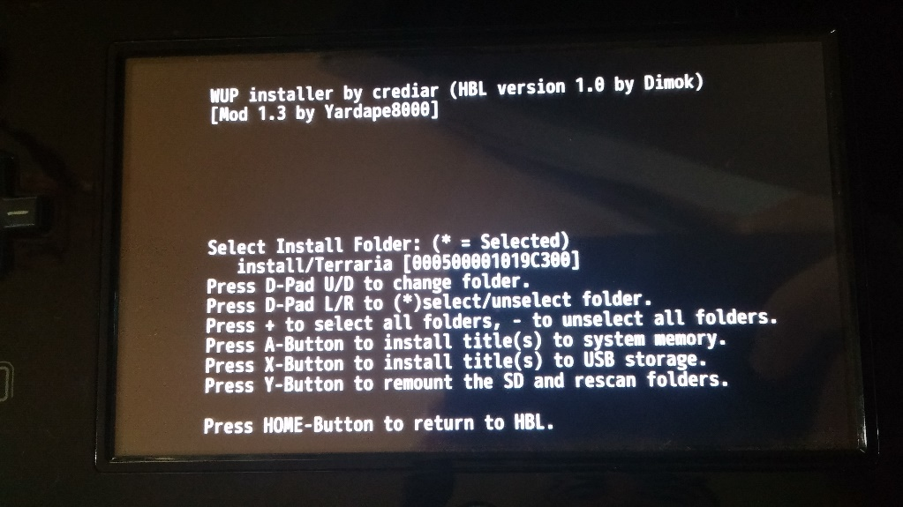
Step 9. Once all Games/Updates/DLC have finished installing you will see the black with white text screen again letting you know everything installed successfully. If not you can check your errors here (https://gbatemp.net/threads/wup-installer-title-installer-firmware-spoofing-3-x-5-4-0.397053/ )Press the home button to get back to the Homebrew channel, then press the home button again to exit. It will bring you to the Mii Maker page. Close out and you will get to the main menu.
Step 10. On your home screen you should now see the game(s) you downloaded to your external hard drive. Play your game! If you installed a regular game that did not say CFW only you will be good to go, just launch the game by clicking on it. If you installed a CFW only game, Virtual Console title, or want to play DLC; you will need to run CFW booter before you will be able to play the game. To do this go back to the Homebrew Channel via the webpage and once there select CFW booter then press load. Your gamepad will turn blank for a second and then you should see a red screen on your Gamepad. This means it is loading. Once it finished you will be back at the system menu but this time you will be able to launch all your CFW only games and play DLC. (NOTE: If you get the
Step 11. Enjoy your games without having to use the disc!

